**Using the Arduino IDE with Node Red to AWS IoT Core**

Setting up the amazon web services

1. Go to [console.aws.amazon.com](http://console.aws.amazon.com/) and Sign up a free account

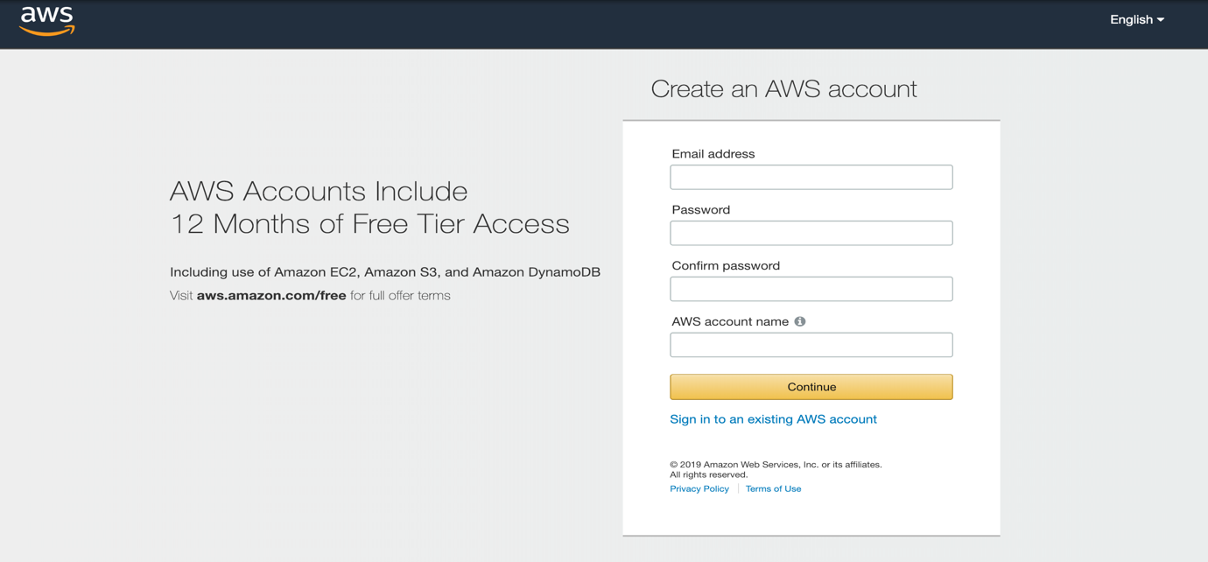

1. Register a thing in IoT Core Services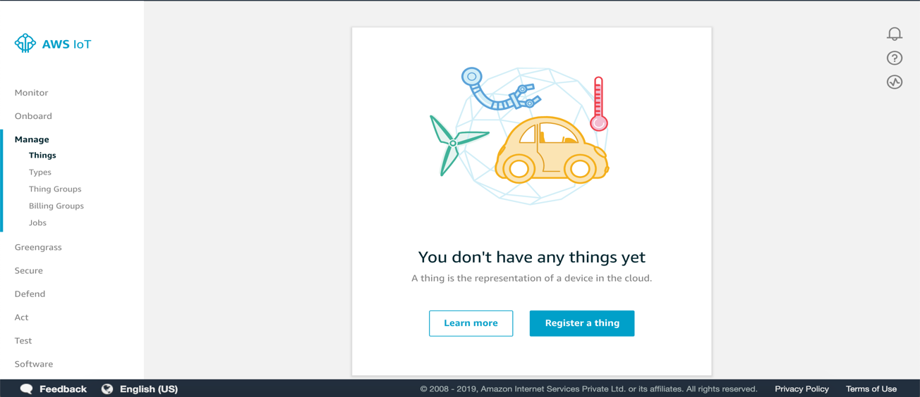
2. Create certificate and Activate it

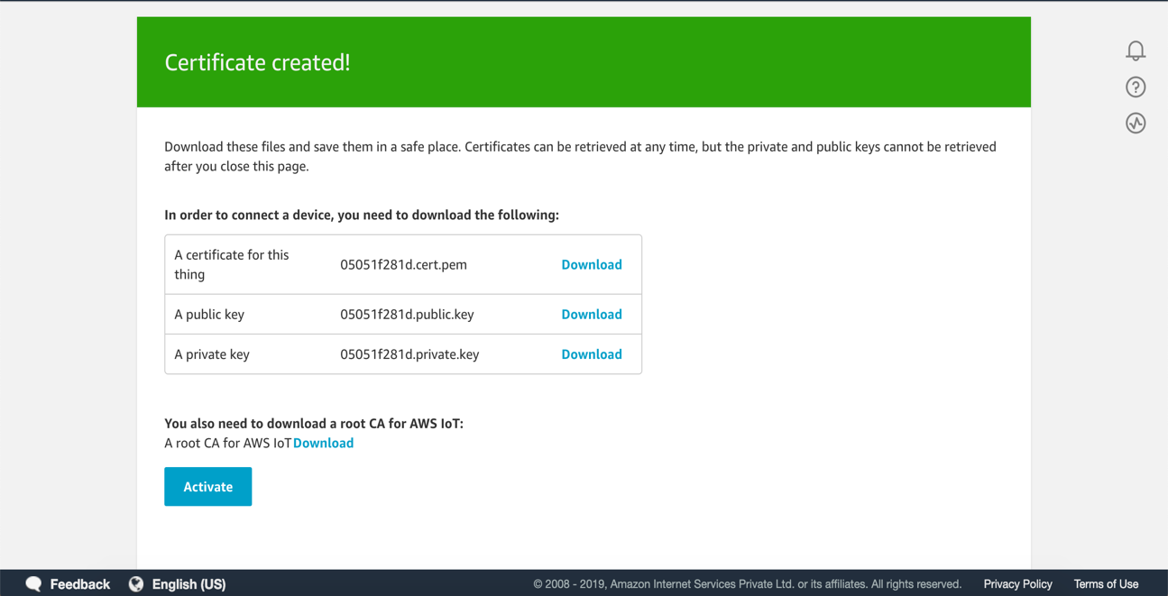

Note : Download the required certificates.

1. Go to IAM -> policies and search for AWSIoTFullAccess and copy the json code and paste it in IoT Core Policies Create a new policy and click on advanced and paste the code in it and click on create .

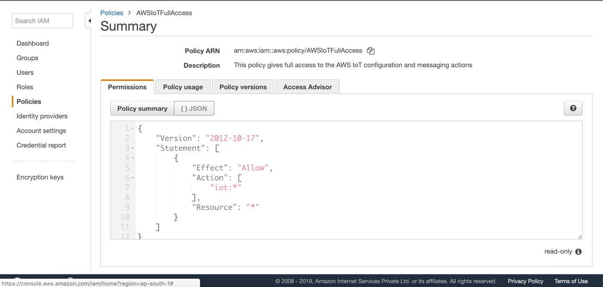

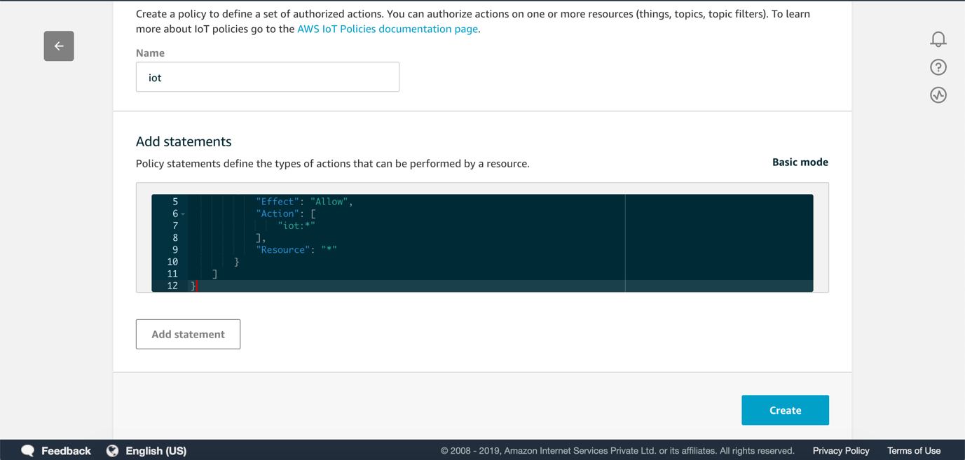

1. Now go to secure -> Certificates and attach the Policy & Thing which we created

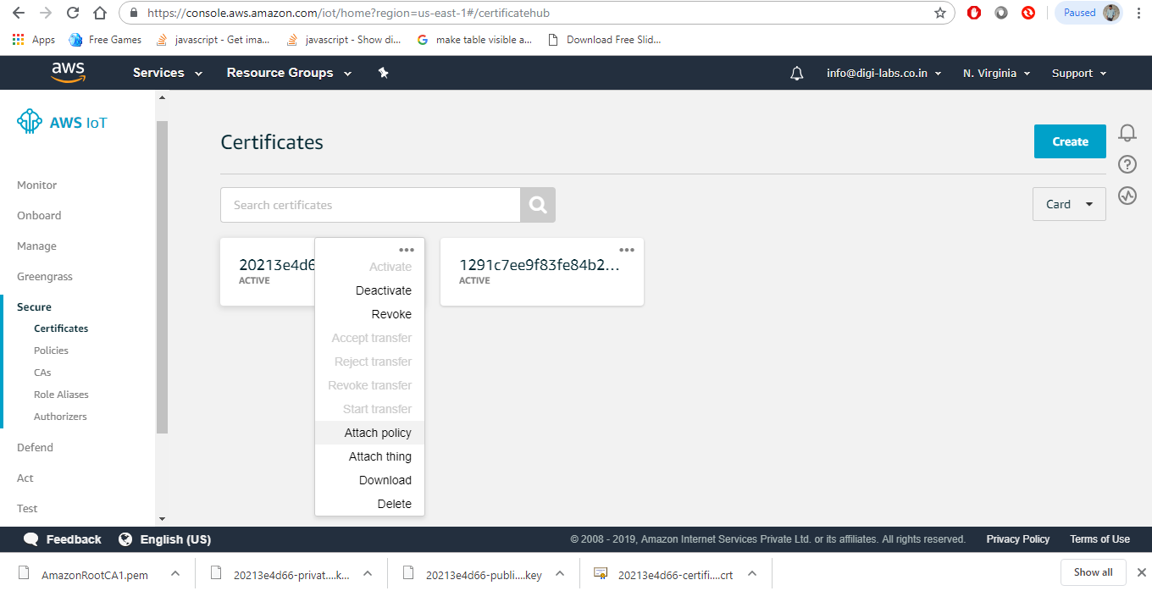

2. Setting up the NodeRed Using mybluemix.net

Firstly, create a free account in mybluemix.net

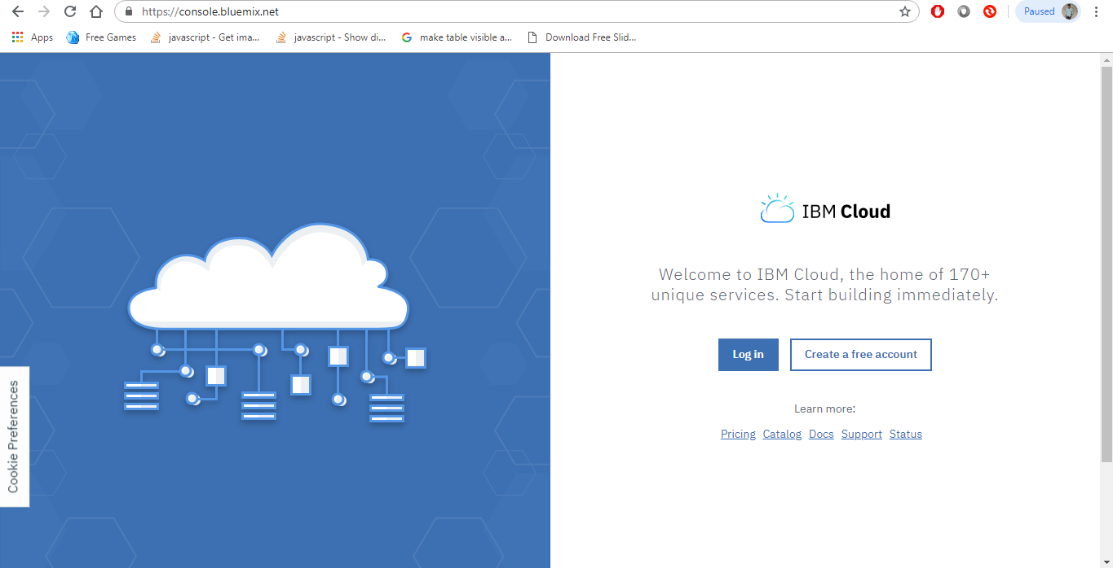

After signing in to the account. In the search box type node-RED

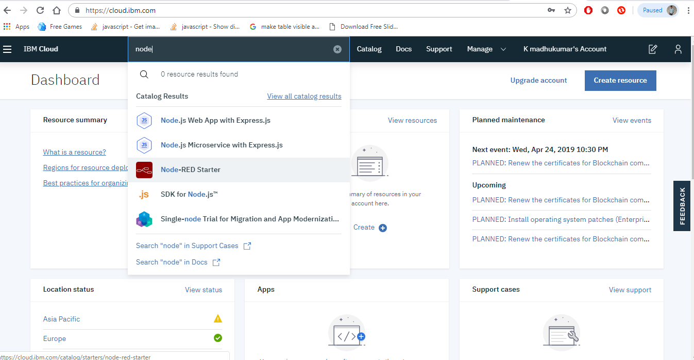

Then select the Node-RED starter from the list and fill the required fields and click on create as shown below

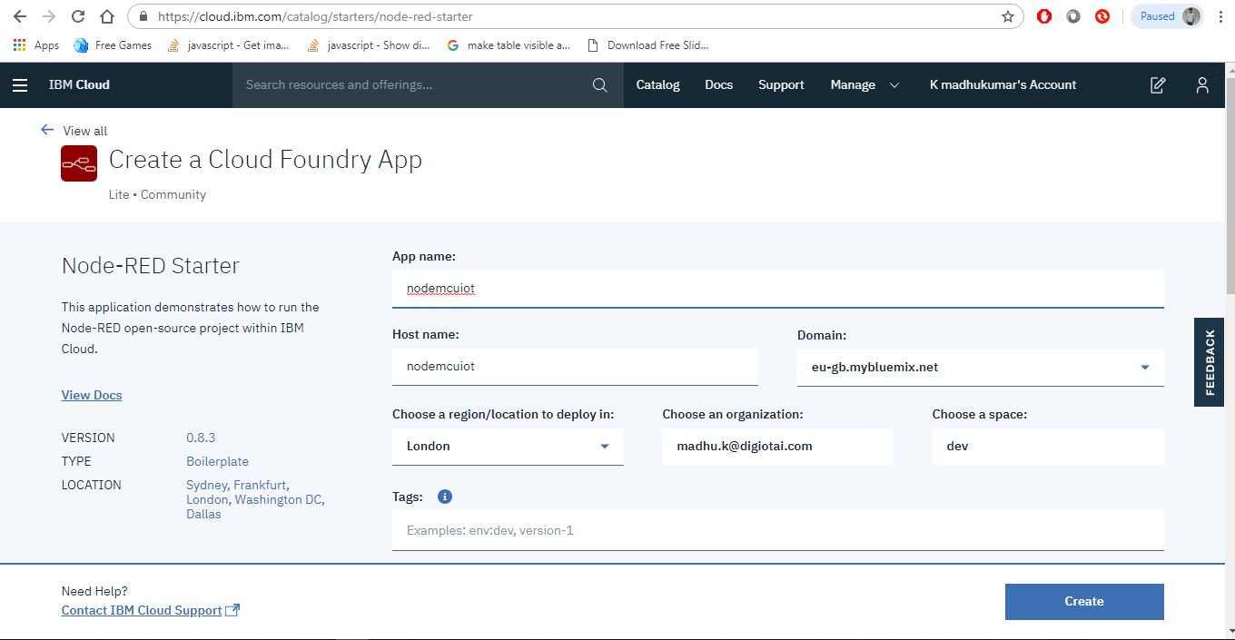

Then click on visit App Url as shown in below

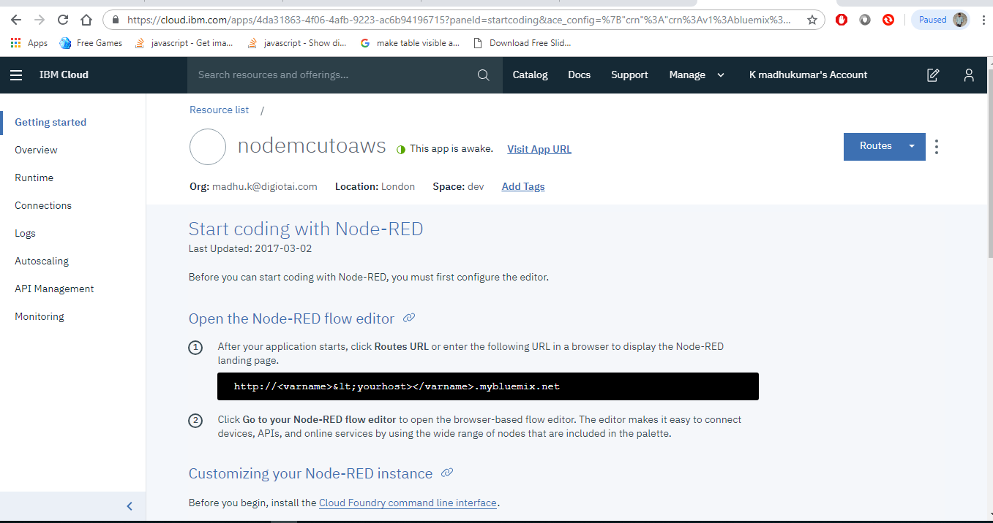

Then follow the steps and finish the process, then the following tab appears

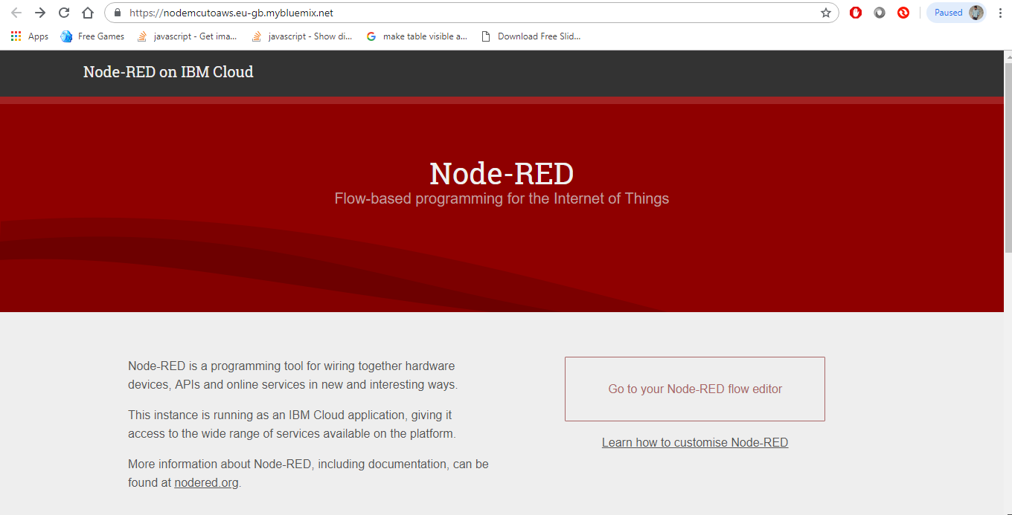

Now click on Go t your Node-RED flow editor

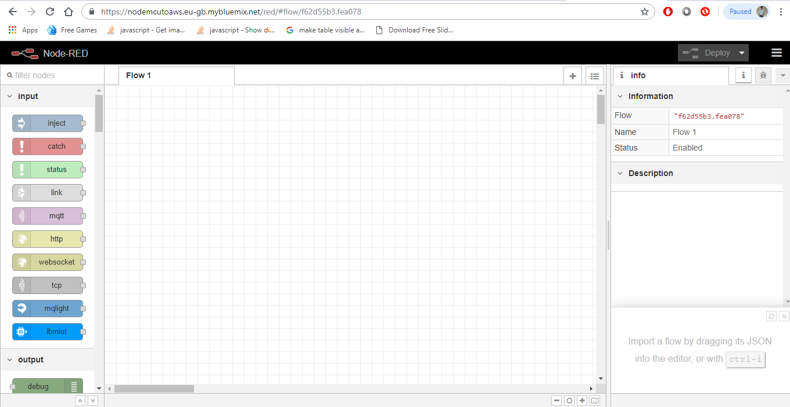

Then configure the connections as follow step by step:

Made the connections as shown in below

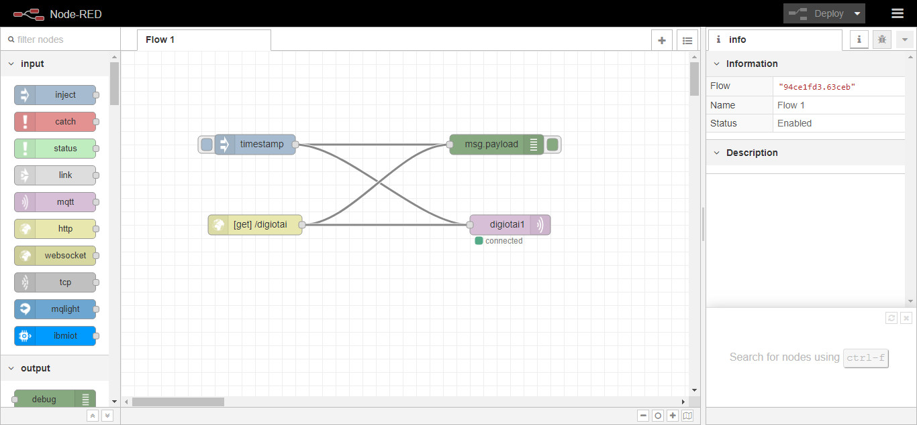

The configuration of Mqtt is shown below

First double click on mqtt then the following tab appears, then click on edit button as shown in below

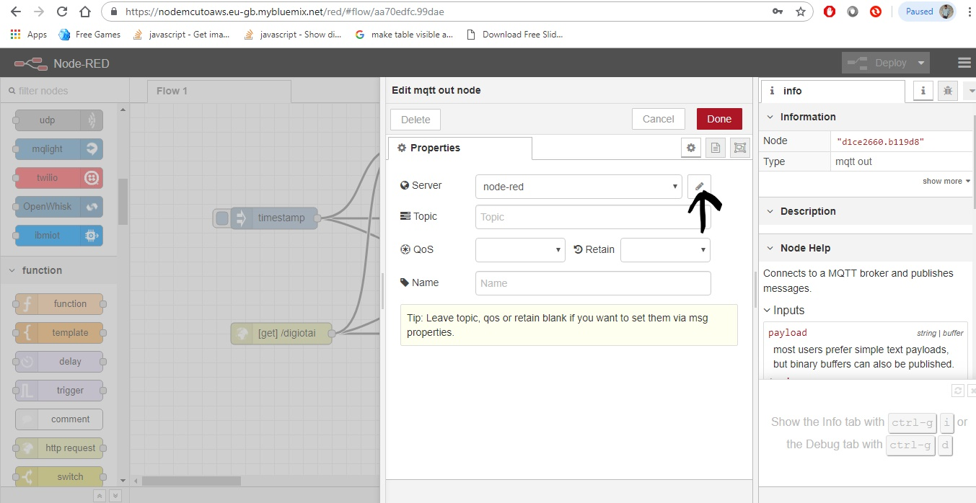

After clicking the edit button the following tab appears

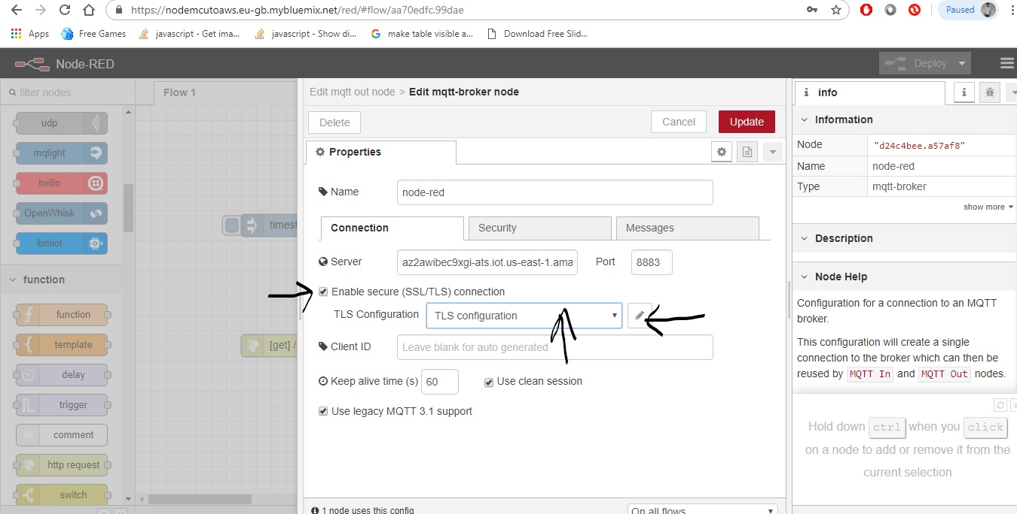

From the above tab first fill the name and server details. The server details are present in the settings in Amazon Web Services as shown in below

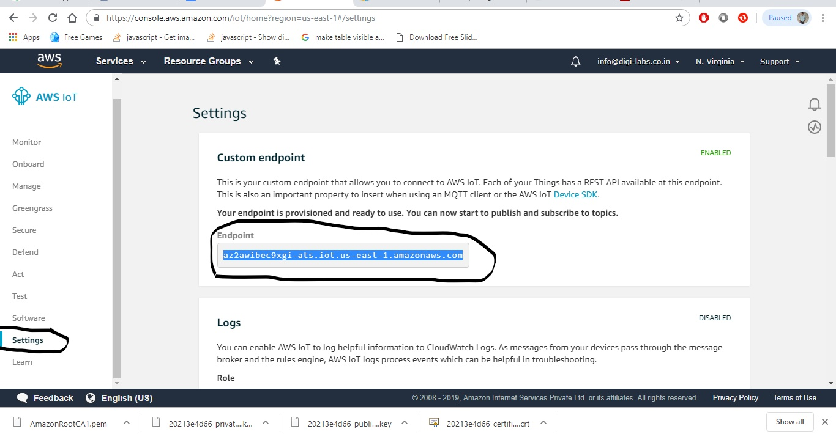

Now enable the “Enable secure (SSL/TLS) connection” and select the TLS Configuration and click on edit button as shown in above.

Then upload the certificates which is downloaded from the Amazon Web Services

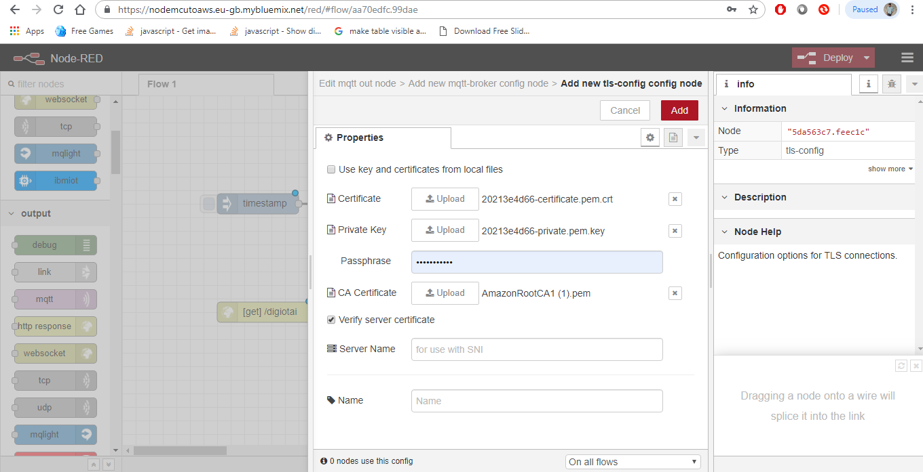

After completing the process don’t forget to click on Deploy Button

Now open the Arduino IDE and paste the code

Now connect your nodemcu to your pc and compile it.

Then go to IoT Core -> Test and subscribe to a topic.

Here you can see the output values